Last Updated: 10/26/2022
This Quick Reference Guide (QRG) outlines the Compensation Manager’s process of accessing Compensation Statements that detail merit award information.

Contents (Quick Links)
Accessing Bulk Statements 1
Accessing Individual Statements 2

Accessing Bulk Statements
Compensation Managers may access bulk Compensation Statements via the Compensation Module.
Individuals with multiple positions must ensure they are logged into the appointment under which they completed merit planning. Please use the instructions below.
Via the OneCampus portal (one.purdue.edu), select Employee Launchpad.

Log in using Purdue Career Account ID and BoilerKey.
If you hold multiple positions, use the Change Selected Employment icon to select the appropriate position. | 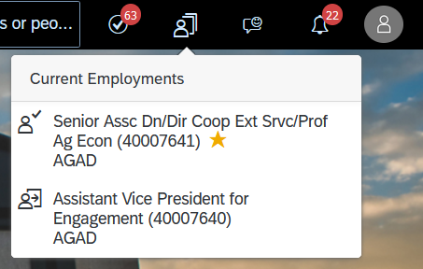
Click the Home menu and then Compensation. | 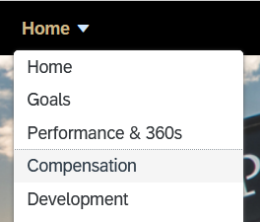
Choose All Forms. Select the applicable Form Title for the current merit worksheet. | 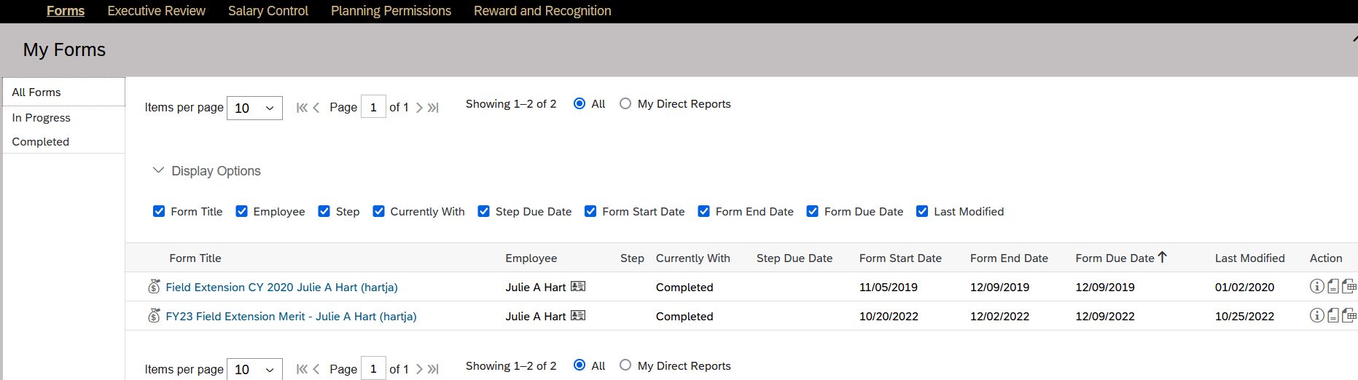
The Merit Planning Worksheet displays. Click on the icon to Bulk Print Statement.  The statements will open in a separate web browser. | 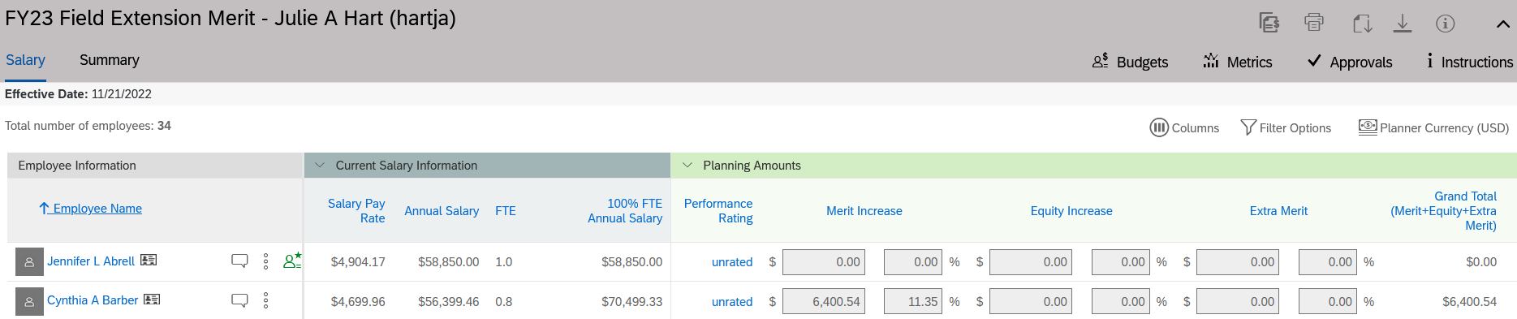

Accessing Individual Statements
Compensation Managers may also access individual compensation statements for those that report up through them.
Go to My Team from the SuccessFactors Home Page.

Choose the Employee you would like to view. Select Compensation Statement. | 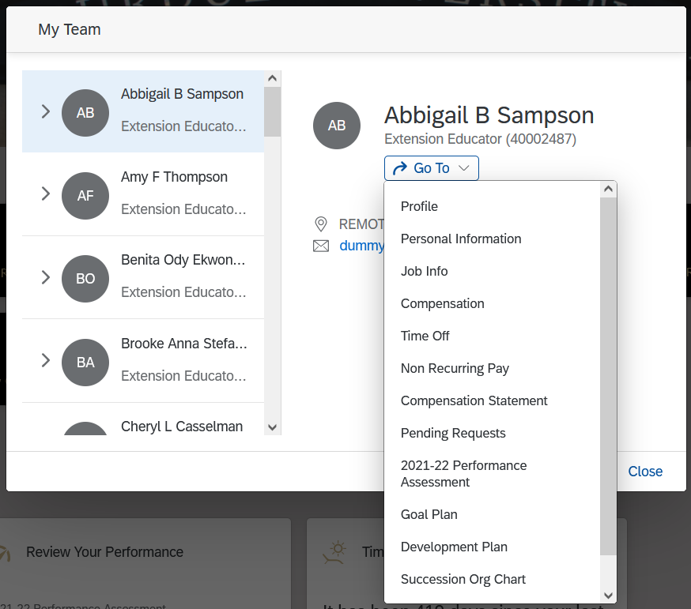
Click the 20XX Merit Planning hyperlink to view the current year’s statement in your browser.  Choose theicon to download a PDF version of the statement. | 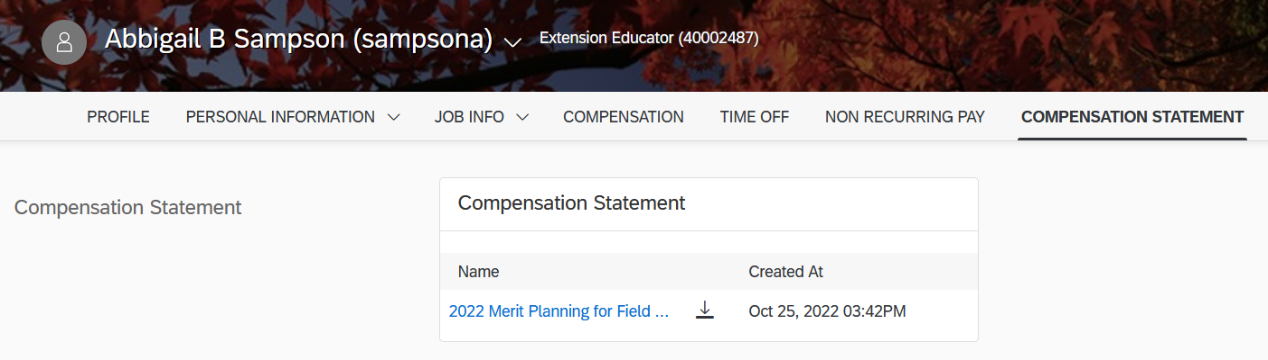
The statement will contain the Performance Rating for staff employees.  For hourly paid employees, it will show the current hourly base pay and annual base pay. For monthly paid employees, it will show the current annual base pay.  The Merit % Increase is the Grand Total % and includes the Merit, Equity and Extra Merit increase.  If an employee was promoted, the promotion $ increase and total % increase will be included.  For hourly paid employees, it will show the new hourly base pay and annual base pay. For monthly paid employees, it will show the new annual base pay.  If an employee receives a lump sum, it will be reflected on the statement as such. | 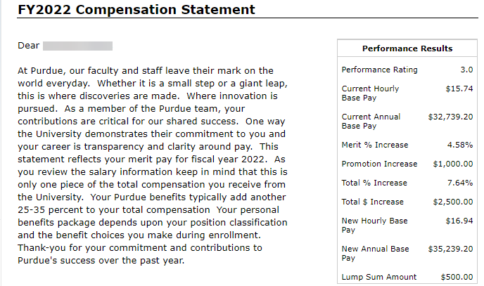
Note: Even if an employee has not received a merit increase, they will receive a Compensation Statement indicating no change in their salary. If you have any questions about the Compensation Statements, please contact your Compensation Analyst or compensation@purdue.edu.

